 京制01050078号

**Operation Manual**

**DMF-1-Series Coriolis Mass Flow Meter**

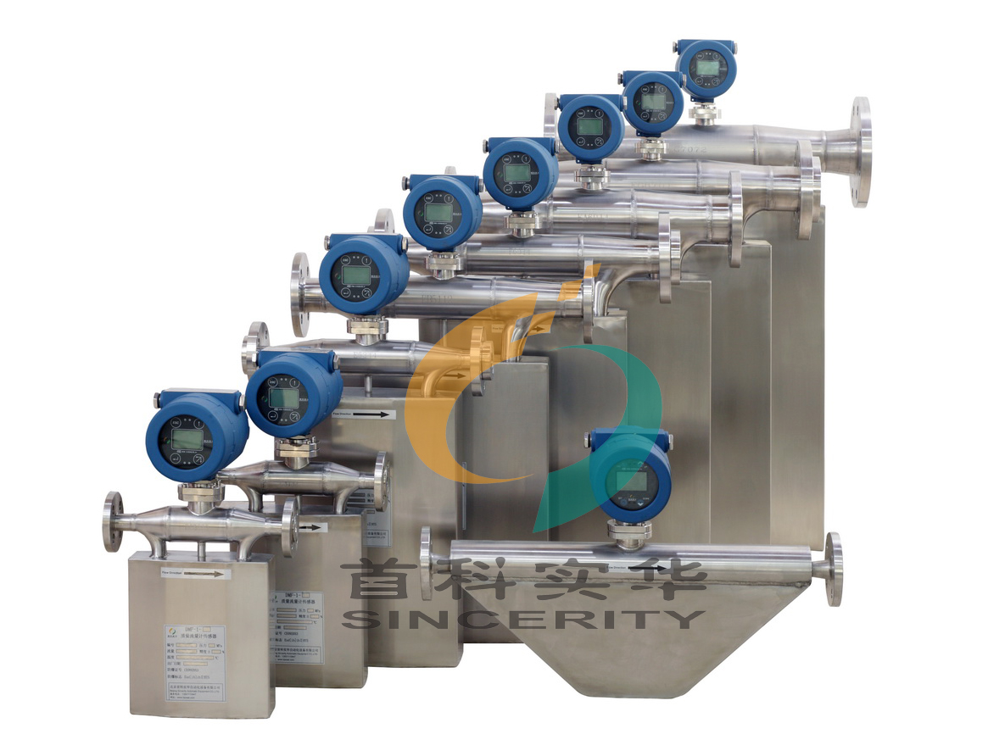

**Beijing Sincerity Automatic Equipment Co., LTD**

Content

Installation& Calibration3

Sensor Installation3

Transmitter & Sensor Connection8

Energizing & Inspection9

Maintenance9

Documentation: Standard RS 485 Communication14

**Installation & Calibration**

**Sensor Installation**

The proper installation is very important for the performance of the Coriolis Mass Flow Meters. The installation location should be chosen the place that easy for the maintenance. Would you please read the content of the chapter carefully before the installations.

1. **Normal Installation, Medium/ Large Scale Coriolis Mass Flow Meter, DMF-1-U10~DMF-1-U150**

It is recommended to release and empty he gas that possibly stored in the pipeline of the Coriolis Mass Flow Meters before installation.



1. **Inverted Installation, Medium/ Large Scale Coriolis Mass Flow Meter, DMF-1-U10~DMF-1-U150**

It is recommended to use the inverted installation for the measurement of Gas (e.g. steam). Because only in this way, the liquid that could possibly stored in the Coriolis Mass Flow Meters could be released and emptied.



1. **Flag- Type Installation, Medium/ Large Scale Coriolis Mass Flow Meter**

Flag- type installation is the installation way that the Coriolis Mass Flow Meter should be vertical to the horizontal line.

The measurement of suspension liquid, and the double-phase liquid of both liquid and solid is recommended to use the flag-type installation. E.g. For the liquid of easy solidification under the change of temperature, and for the liquid of high viscosity, it is required to empty the liquid left in the measuring pipeline after the measurement. The flag-type installation will not influence the measuring accuracy of the any types of liquid measured. But the direction of the measured flowing must be from bottom up.



1. **Tiny Pipe-Size (DMF-1-S3~ DMF-1-S8) Installation**

The tiny- size Coriolis Mass Flow Meters’ flow range is very small, while the requirement about the accuracy is high. In this way, then the stable mounting plate and bracket are the must. The installation of mounting plate and Coriolis Mass Flow Meter must be completely flat without any space. If not, please use the level bolt to adjust the balance. The installation of the tiny- size Coriolis Mass Flow Meters is shown as below:

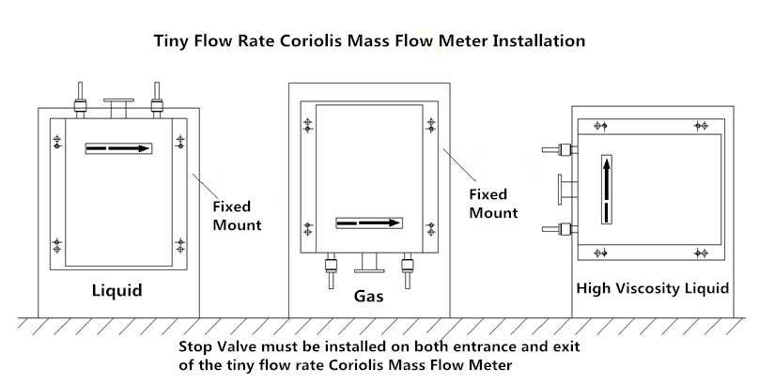

1. **Other Installation Requirements**
2. Coriolis Mass Flow Meters’ measuring principle is based on the controlled generation of vibration. So the installation location should be as far away from the vibration source as possible. And the stable support of the installation pipeline is required too. If the vibration source is inevitable, then it is recommended to use the hose connection. The connecting pipeline and the Coriolis Mass Flow Meter’s connection should be located in the same axis. And do not impose an additional force on mass flow meter. Unnecessary additional force will affect measuring accuracy.
3. If the installation of the throttle device is required, such as the flow control valve, then the installation must be installed at the export of the Coriolis Mass Flow Meter.
4. The cut-off valves should be installed at the entry and the export of the Coriolis Mass Flow Meters. And it is benefit for the first-time zero point calibration after the installation.
5. The Coriolis Mass Flow Meter should be as far away from the pump’s export as possible, especially the reciprocating pumps. The fluctuation of the flow measurement would be caused by getting too close to the pumps.
6. For the measurement of high temperature liquid, and the heat preservation is required, the insulation shell and the heating pipe must not directly contact with the sensor of the Coriolis Mass Flow Meters. Our company could provide the heat conduction specially designed for the Coriolis Mass Fow Meters Sensors. We could provide the steam heating, or the conduction oil heating.e could provide the steam heating, or the conduction oil heating. (Should be ordered in advance)
7. The measured liquid should be at a suitable flow state. If the flow state of the liquid is not suitable under the natural environment conditions, then the external improvement is required. It could be used to regulate the temperature of the fluid (heating/ cooling temperature), to make the current fluid to be at the right flow state.
8. Installation Direction: Please make sure that the direction of fluid flowing through the pipeline is the same direction with the arrow on the nameplate of Coriolis Mass Flow Meter.
9. The serial number of the sensor and the transmitter should be one-to-one correspondence. The change or replacement may cause the measurement error of the Coriolis Mass Flow Meters.

**Transmitter& Sensor Connection:**

The integration of the Coriolis Mass Flow Meter has been connected and installed before the delivery.

The separated transmitter and the sensor are connected by the special connection cables and connectors. If the separation installation of the transmitter and the sensor is required, please contact us in advance before placing the order. The maximum length should not exceed 300m.

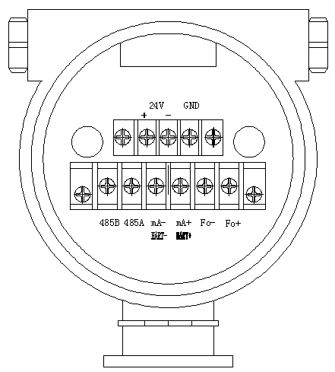

24V + \– 24VDC Power Supply (Current should not less than 500mA)

Fo + \– Frequency Output (instantaneous mass flow or volume flow)

mA + \– Current Output (instantaneous flow or density optional)

**（HART + \–） HART**

485A \485B RS-485 Communication (Baud Rate: “9600”, Address: “1”)

GND Signal Shielding



Instrument Shell

|  |
| --- |
| **Attention** |
| **The output frequency of the transmitter and the current output must not connect with any level of external power source.** |
| **Please refer to the anti-explosion part for the technical parameters about the dangerous occasions.** |

**Energizing & Inspection:**

1. **Please make sure that the wiring connection is correct before energizing the Coriolis Mass Flow Meters.**

The fault line protection is designed in the transmitters of the Coriolis Mass Flow Meters. But the wrong wiring connection may still cause the damage of the mass flow meters. So please make sure that the wiring connection is correct before energizing the Coriolis Mass Flow Meters.

1. **The screen will display “Initializing, hold on…” after the energizing**

**Calibration**

**The zero point calibration is required after the Coriolis Mass Flow Meter installation. Please fill in large amount of measured medium for 10 minutes before the zero point calibration.**

The zero point calibration is used to provide the benchmark of the flow measurement. The zero point must be processed after the first-time calibration or re-installation. Please make sure firstly it is required to turn off the stop valve at the exit of the mass flow meter, and then turn off the stop valve at the entrance. And make sure the liquid fulfilled the sensor is comparatively at the stationary state during the calibration. The detailed operation methods are listed as below:

1. **Instrument Panel**

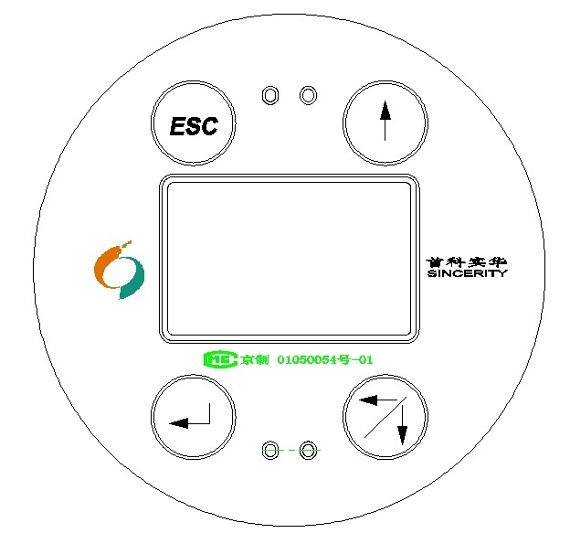

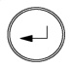

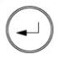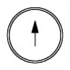Touch ，and the password interface would be shown. Touch ，and touch , input 20 (password). Then touch to enter.

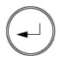

Touch to enter the next menu.



Records

Setting

Output Test

Clear Fault Code

Touch to scroll between several interfaces to check the information of the mass flow meters

**Setting**



touch to enter the “Setting” interface.

Records

Setting

Output Test

Clear Fault Code

In the setting interface, total flow clearance, zero point calibration, tiny-signal cut, current output could be processed.

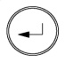

**Touch to enter**

 For Example: 1) when the cursor is at “Clear”, touch to move to “Zero Point Calibrate”;

Clear

No

Zero Point Calibrate

No

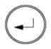

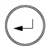2) Touch to enter, touch to choose yes, or no. Touch to enter. Or touch “ESC” to exit.

It would take approximately 1 minute to process the zero point calibration. The mass flow meter will transfer to the demonstrating interface automatically afterwards.

If it is required to modify the parameters associated with the mass flow meter calibration, please contact our after-sales department, and conduct under the guidance of the related engineers. Thank you

**Maintenance:**

|  |  |  |
| --- | --- | --- |
| **Symptom** | **Failure Reason** | **Solution** |
| **No display** | Check whether is 24VDC power supply is normal | Make sure 24VDC is working normally |
| **Fluctuation of flow rate measured is large** | Whether there’s strong vibration of the line connected to the sensor | Adding support or switching to hose connection |
| **Could not enter the measuring interface after the boot** | Do not connect with the sensor | Check the cables, and make sure they are connected to the sensor properly |
| **Zero Point Drift is large** | The installation of the sensor has stress | The connecting line and the sensor interfaces should be at the same axis |

*Attention: (0-10)KHz and (4-20)mA output signal is already with the power supply. It is forbidden to connect with other external power sources. Otherwise the damage of the mass flow meter could be caused.*

|  |  |  |  |  |
| --- | --- | --- | --- | --- |
| Beijing Sincerity DSP Instrument Modbus RUT Address Table | | | | |
| S/N | Register | Address (Hexadecimal/Decimal) | Context Menu | Note |
| 1 | 41001 | 0x03E8 / 1000 | Instant Mass Flow |  |
| 2 | 41003 | 0x03EA / 1002 | Total Mass Flow |  |
| 3 | 41005 | 0x03EC / 1004 | Instant Volume Flow |  |
| 4 | 41007 | 0x03EE / 1006 | Total Volume Flow |  |
| 5 | 41009 | 0x03F0 / 1008 | Density |  |
| 6 | 41011 | 0x03F2 / 1010 | Temperature |  |
| 7 | 41013 | 0x03F4 / 1012 | Content of component A |  |
| 8 | 41015 | 0x03F6 / 1014 | Intrinsic Parameter |  |
| 9 | 41017 | 0x03F8 / 1016 | Intrinsic Parameter |  |
| 10 | 41019 | 0x03FA / 1018 | Intrinsic Parameter |  |
| 11 | 41021 | 0x03FC / 1020 | Intrinsic Parameter |  |
| 12 | 41023 | 0x03FE / 1022 | Intrinsic Parameter |  |
| 13 | 41025 | 0x0400 / 1024 | Intrinsic Parameter |  |
| 14 | 41027 | 0x0402 / 1026 | Intrinsic Parameter |  |
| 15 | 41029 | 0x0404 / 1028 | Intrinsic Parameter |  |
| 16 | 41031 | 0x0406 / 1030 | Intrinsic Parameter |  |
| 17 | 41033 | 0x0408 / 1032 | Intrinsic Parameter |  |
| 18 | 41035 | 0x040A / 1034 | Intrinsic Parameter |  |
| 19 | 41037 | 0x040C / 1036 | Intrinsic Parameter |  |
| 20 | 41039 | 0x040E / 1038 | Intrinsic Parameter |  |
| 21 | 41041 | 0x0410 / 1040 | Intrinsic Parameter |  |
| 22 | 41043 | 0x0412 / 1042 | Intrinsic Parameter |  |
| 23 | 41045 | 0x0414 / 1044 | Intrinsic Parameter |  |
| 24 | 41047 | 0x0416 / 1046 | Intrinsic Parameter |  |
| 25 | 41049 | 0x0418 / 1048 | Intrinsic Parameter |  |
| 26 | 41051 | 0x041A / 1050 | Intrinsic Parameter |  |
| 27 | 41053 | 0x041C / 1052 | Intrinsic Parameter |  |
| 28 | 41055 | 0x041E / 1054 | Intrinsic Parameter |  |
| 29 | 41057 | 0x0420 / 1056 | Intrinsic Parameter |  |
| 30 | 41059 | 0x0422 / 1058 | Intrinsic Parameter |  |
| 31 | 41061 | 0x0424 / 1060 | Intrinsic Parameter |  |
| 32 | 41063 | 0x0426 / 1062 | Intrinsic Parameter |  |
| 33 | 41065 | 0x0428 / 1064 | Intrinsic Parameter |  |
| 34 | 41067 | 0x042A / 1066 | Intrinsic Parameter |  |
| 35 | 41069 | 0x042C / 1068 | Intrinsic Parameter |  |
| 36 | 41071 | 0x042E / 1070 | Intrinsic Parameter |  |
| 37 | 41073 | 0x0430 / 1072 | Intrinsic Parameter |  |
| 38 | 41075 | 0x0432 / 1074 | Intrinsic Parameter |  |
| 39 | 41077 | 0x0434 / 1076 | Cumulative Clearance |  |
| 40 | 41079 | 0x0436 / 1078 | Intrinsic Parameter |  |
| 41 | 41081 | 0x0438 / 1080 | Intrinsic Parameter |  |
| 42 | 41083 | 0x043A / 1082 | Intrinsic Parameter |  |
| 43 | 41085 | 0x043C / 1084 | Intrinsic Parameter |  |
| 44 | 41087 | 0x043E / 1086 | Intrinsic Parameter |  |
| 45 | 71089 | 0x0440/ 1088 | Intrinsic Parameter |  |
| 46 | 41091 | 0x0442 / 1090 | Intrinsic Parameter |  |
| 47 | 41093 | 0x0444 / 1092 | Intrinsic Parameter |  |
| 48 | 41095 | 0x0446 / 1094 | Intrinsic Parameter |  |
| 49 | 41097 | 0x0448 / 1096 | Intrinsic Parameter |  |
| 50 | 41099 | 0x044A / 1098 | Intrinsic Parameter |  |
| 51 | 41101 | 0x044C / 1100 | Intrinsic Parameter |  |
| 52 | 41103 | 0x044E / 1102 | Intrinsic Parameter |  |
| 53 | 41105 | 0x0450 / 1104 | Zero Point Calibration | It is required to make sure the medium is fully filled in pipeline and motionless |
| 54 | 41107 | 0x0452 / 1106 | Intrinsic Parameter |  |
| 55 | 41109 | 0x0454 / 1108 | Intrinsic Parameter |  |
| 56 | 41111 | 0x0456 / 1110 | Intrinsic Parameter |  |
|  |  |  |  |  |
| Communication Settings： | | |  |  |
| 1.Factory Settings，Baud Rate：9600，Data bits：8，Stop Bit：1，Parity Check: None | | | | |
| 2.The communication parameters can be modified inside the mass flow meters. | | | | |
| 3.All datas are floating point numbers. | | |  |  |

Attention:

Each holding register is 4 bytes (2 consecutive maintain registers), and it takes two addresses (low address). The register with a background in the tables is read-only register. The writing operation is invalid.

The address of 0x41049 is total-data clearance register. Write 0 in this address could process the clearance operation. Read the register and it will returns back to 1 (Floating point number).

The flow unit setting is 0-7 (The data will be transferred to 4-byte floating point number to transfer).

0🡺t/h；1🡺kg/h；2🡺g/h；3🡺kg/min ；4🡺g/min；5🡺m3/h；6🡺L/min；7🡺ml/min

The density unit setting is 0-2 (The data will be transferred to 4-byte floating point number to transfer). And it respectively stands for: g/cm3、g/L、t/m3

0🡺 g/cm3；1🡺g/L；2🡺t/m3

The current output selection is 0-1. And it respectively stands for flow and density. The data will be transferred to 4-byte floating point number to transfer.

The measured medium setting is 0-1. And it respectively stands for liquid and gas. The data will be transferred to 4-byte floating point number to transfer.

ModBus Communication (RTU Format)

Check Method: no check

Data Bits: 8

Stop Bits: 1

**ModBus Communication Protocol (RTU)**

1. Read N variables

The host requested information frame:

Mass Flow Meter Address+0x03+Register’s Starting Address（2bytes，High Byte is in the front）+ Number of Register’s Reading and Writing 2*N（2bytes，High Byte is in the front）+ CRC Check Code（2bytes，Low Byte is in the front）

Response Information from the machine frame:

Mass Flow Meter Address +0x03+Bytes of Data 4*N（1字节） + Register’s Data（4*N bytes，High Byte is in the front）+ CRC Check Code（2 bytes，Low Byte is in the front）

For Example:

1. Write N variables

The host requested information frame:

Mass Flow Meter Address +Function Code 0x10+ Register’s Starting Address（2 bytes，High Byte is in the front）+ Number of Register’s Reading and Writing 2*N（2bytes，High Byte is in the front） + Bytes of Data 4*N（1byte） +Data waiting to be written（4*N bytes，High Byte is in the front）+ CRC Check Code（2 bytes，Low Byte is in the front）

Response Information from the machine frame:

Mass Flow Meter Address + Function Code 0x10+ Register’s Starting Address（2 bytes，High Byte is in the front）Number of Register’s Reading and Writing 2*N（2bytes，High Byte is in the front）+

（2 bytes，Low Byte is in the front）



**Beijing Sincerity Automatic Equipment CO.，LTD**

**Company address：No. 8 building, 3rd. district,I-Town, Gaoli Zhang road，Haidian District,Beijing, China**

**Zip Code：100095**

**Fax：+86-010-62469399**

**Tel：+86-010-62469399/62468399**

**Contact: Ms. Zoe Pan**

**Phone: +86-18600270515**

**Web：[www.bjssae.com](http://www.bjssae.com)**